Midpoint of a Segment in Solid Geometry
# Source: AI Source: Provided by: [Data Path: Persons Table -> ID Column: 1, Name_En Column: Motasem Essam] -> From: [ChatGPT] on [7/25/2026]
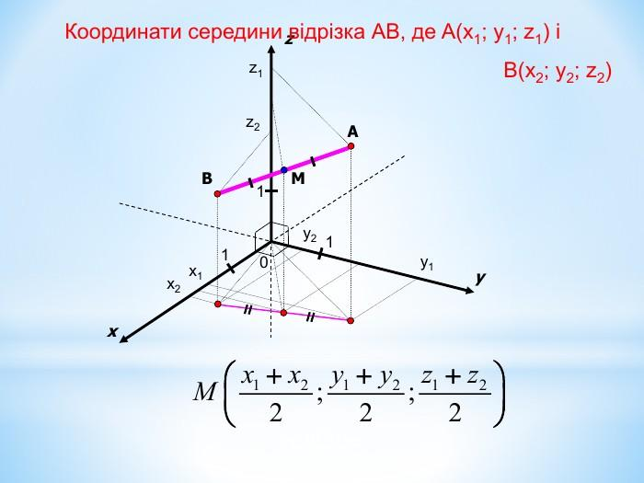
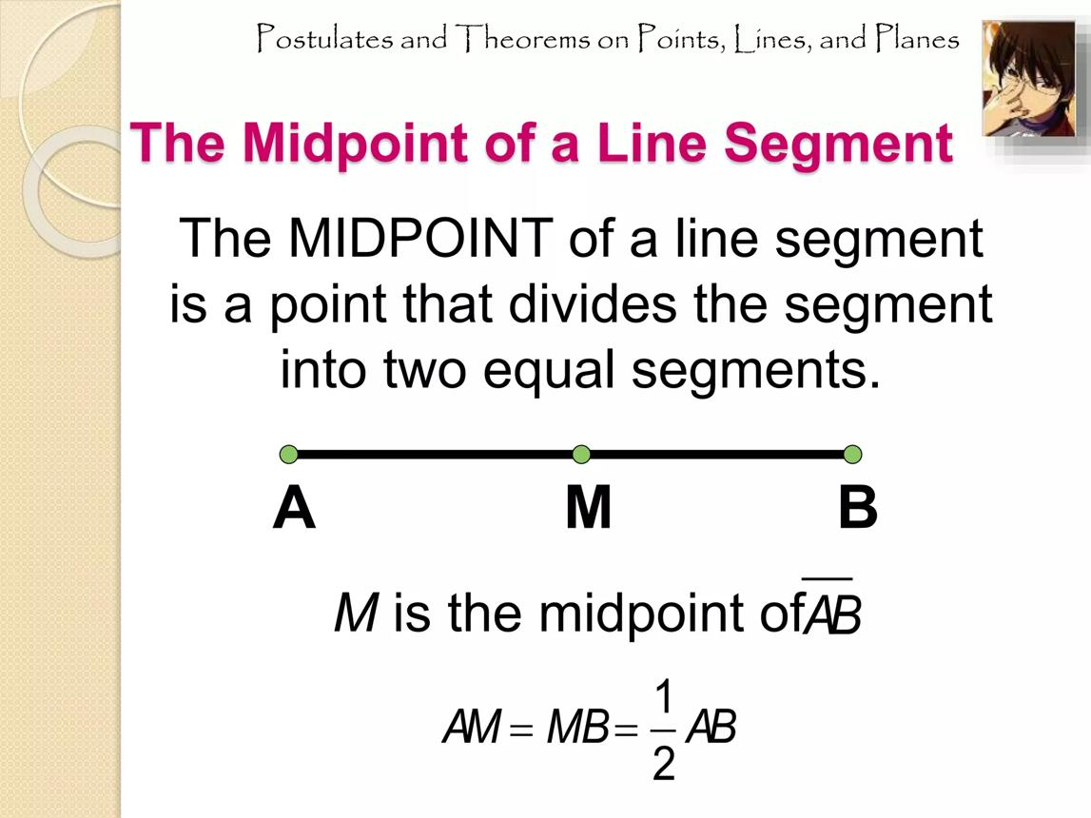
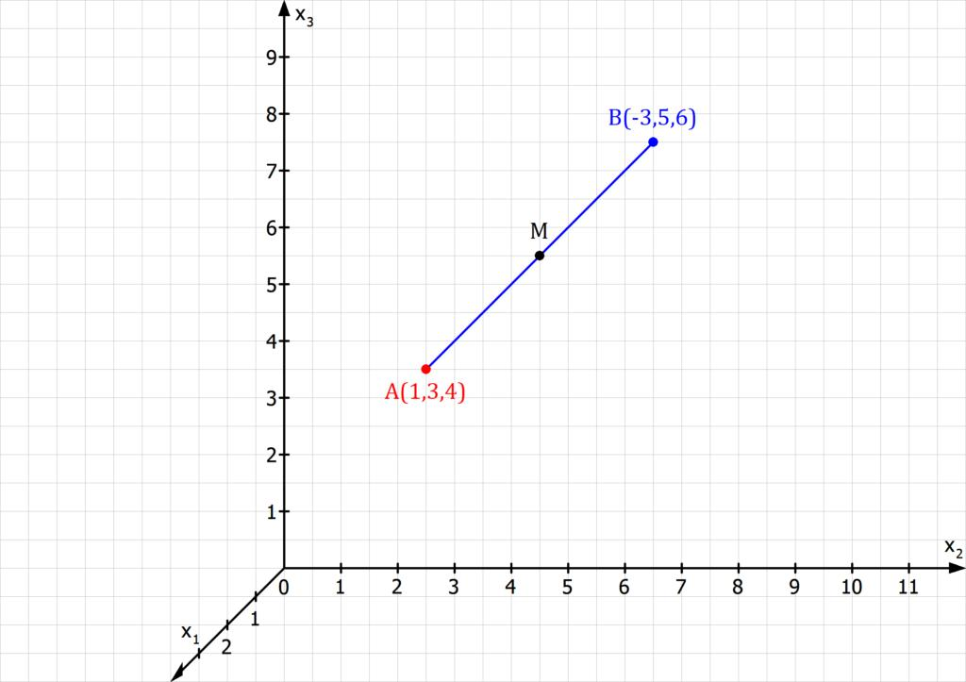

Definition
# Source: AI Source: Provided by: [Data Path: Persons Table -> ID Column: 1, Name_En Column: Motasem Essam] -> From: [ChatGPT] on [7/25/2026]
The midpoint of a line segment in solid geometry is the point located exactly halfway between the two endpoints of a line segment in three-dimensional space.
If a segment has endpoints $A$ and $B$, its midpoint $M$ divides the segment into two equal parts:
$$\boxed{AM=MB}$$
The midpoint lies on the original segment, not beyond either endpoint. It applies to segments in any direction in 3D space, including edges, face diagonals, and space diagonals of solids.

Simple definition
# Source: AI Source: Provided by: [Data Path: Persons Table -> ID Column: 1, Name_En Column: Motasem Essam] -> From: [ChatGPT] on [7/25/2026]
The midpoint is the exact middle point of a line segment, equally distant from both endpoints.
$$\boxed{AM=MB=\frac{AB}{2}}$$
M is halfway between A and B.

Key characteristics
# Source: AI Source: Provided by: [Data Path: Persons Table -> ID Column: 1, Name_En Column: Motasem Essam] -> From: [ChatGPT] on [7/25/2026]
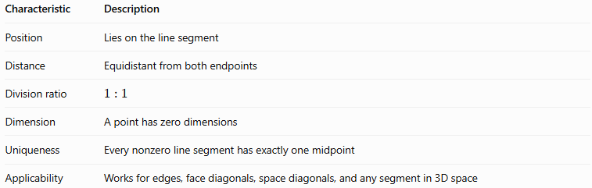
Characteristic | Description
Position | Lies on the line segment
Distance | Equidistant from both endpoints
Division ratio | $$1:1$$
Dimension | A point has zero dimensions
Uniqueness | Every nonzero line segment has exactly one midpoint
Applicability | Works for edges, face diagonals, space diagonals, and any segment in 3D space

Types and examples of midpoints in solid geometry

A. Midpoint of an edge
# Source: AI Source: Provided by: [Data Path: Persons Table -> ID Column: 1, Name_En Column: Motasem Essam] -> From: [ChatGPT] on [7/25/2026]
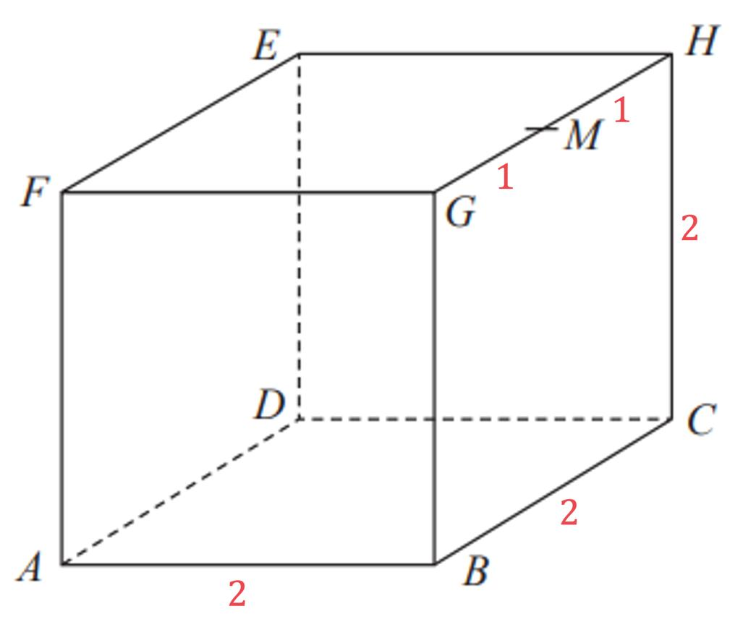
The midpoint of an edge is halfway along a solid's edge.
If an edge has length $a$, then:
$$AM=MB=\frac{a}{2}$$
Example: If a cube has an edge of $10\text{ cm}$, its edge midpoint divides it into two segments of $5\text{ cm}$ each.

B. Midpoint of a face diagonal
# Source: AI Source: Provided by: [Data Path: Persons Table -> ID Column: 1, Name_En Column: Motasem Essam] -> From: [ChatGPT] on [7/25/2026]
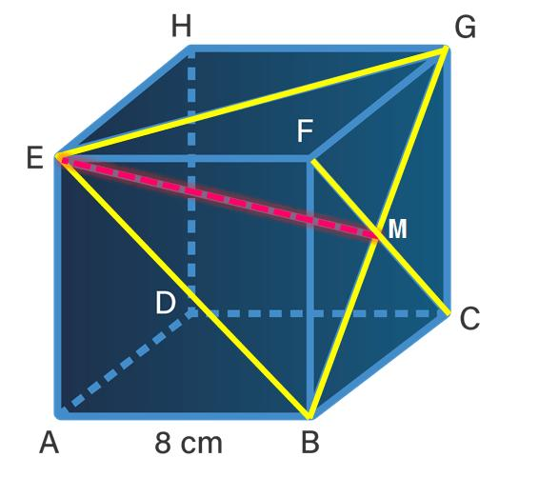
The midpoint of a face diagonal is halfway between two vertices of the same face.
For a square face with side $a$, the diagonal length is $a\sqrt{2}$. Therefore:
$$AM=MB=\frac{a\sqrt{2}}{2}$$
For a square face, this midpoint is also the center of the square.

C. Midpoint of a space diagonal
# Source: AI Source: Provided by: [Data Path: Persons Table -> ID Column: 1, Name_En Column: Motasem Essam] -> From: [ChatGPT] on [7/25/2026]
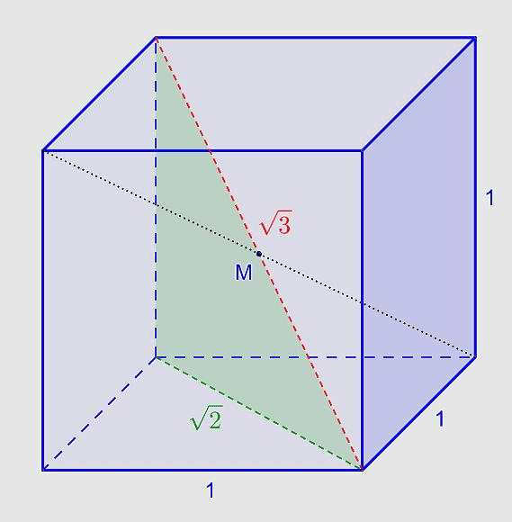
The midpoint of a space diagonal lies halfway between opposite vertices, through the interior of the solid.
For a cube with edge length $a$, its space diagonal is $a\sqrt{3}$, so:
$$AM=MB=\frac{a\sqrt{3}}{2}$$
For a cube or cuboid, the midpoint of every space diagonal is the center of the solid.

Mathematical formulas

A. Midpoint formula in three-dimensional coordinates
# Source: AI Source: Provided by: [Data Path: Persons Table -> ID Column: 1, Name_En Column: Motasem Essam] -> From: [ChatGPT] on [7/25/2026]
Suppose the endpoints are:
$$A\left(x_{1},y_{1},z_{1}\right), B\left(x_{2},y_{2},z_{2}\right)$$
The midpoint $M$ is calculated by averaging the corresponding coordinates:
$$\boxed{M=\left(\frac{x_{1}+x_{2}}{2},\frac{y_{1}+y_{2}}{2},\frac{z_{1}+z_{2}}{2}\right)}$$
Average the two x-coordinates, the two y-coordinates, and the two z-coordinates separately.

B. Midpoint formula using vectors
# Source: AI Source: Provided by: [Data Path: Persons Table -> ID Column: 1, Name_En Column: Motasem Essam] -> From: [ChatGPT] on [7/25/2026]
If the position vectors of $A$ and $B$ are $a$ and $b$, respectively, then the midpoint's position vector is:
$$\boxed{m=\frac{a+b}{2}}$$
This formula is useful in vector geometry and 3D modeling.

C. Finding a missing endpoint
# Source: AI Source: Provided by: [Data Path: Persons Table -> ID Column: 1, Name_En Column: Motasem Essam] -> From: [ChatGPT] on [7/25/2026]
If $M$ is the midpoint of $AB$, and $A$ and $M$ are known, the coordinates of $B$ can be found using:
$$\boxed{B=2M-A}$$
In coordinates:
$$\boxed{\begin{aligned}x_{2}&=2x_{M}-x_{1} \\ y_{2}&=2y_{M}-y_{1} \\ z_{2}&=2z_{M}-z_{1}\end{aligned}}$$

D. Distance from an endpoint to the midpoint
# Source: AI Source: Provided by: [Data Path: Persons Table -> ID Column: 1, Name_En Column: Motasem Essam] -> From: [ChatGPT] on [7/25/2026]
If the total length of the segment is $d$, then:
$$\boxed{AM=MB=\frac{d}{2}}$$
For a general segment with endpoints in 3D space:
$$d=\sqrt{{\left(x_{2}-x_{1}\right)}^{2}+{\left(y_{2}-y_{1}\right)}^{2}+{\left(z_{2}-z_{1}\right)}^{2}}$$
Therefore:
$$\boxed{AM=MB=\frac{1}{2}\sqrt{{\left(x_{2}-x_{1}\right)}^{2}+{\left(y_{2}-y_{1}\right)}^{2}+{\left(z_{2}-z_{1}\right)}^{2}}}$$

Worked examples
# Source: AI Source: Provided by: [Data Path: Persons Table -> ID Column: 1, Name_En Column: Motasem Essam] -> From: [ChatGPT] on [7/25/2026]
Example 1: Find the midpoint in 3D space
Given the endpoints:
$$A\left(2,4,6\right), B\left(8,10,14\right)$$
Find the midpoint $M$.
Step 1: Apply the formula.
$$M=\left(\frac{x_{1}+x_{2}}{2},\frac{y_{1}+y_{2}}{2},\frac{z_{1}+z_{2}}{2}\right)$$
Step 2: Substitute the coordinates.
$$M=\left(\frac{2+8}{2},\frac{4+10}{2},\frac{6+14}{2}\right)$$
Step 3: Calculate.
$$M=\left(5,7,10\right)$$
$$Answ\boxed{M(5,}7,10)\}$$
Example 2: Find the midpoint of a cube's space diagonal
A cube has edge length $4\text{ cm}$. Two opposite vertices are $A\left(0,0,0\right)$ and $B\left(4,4,4\right)$.
Step 1: Apply the midpoint formula.
$$M=\left(\frac{0+4}{2},\frac{0+4}{2},\frac{0+4}{2}\right)$$
Step 2: Simplify.
$$\boxed{M=\left(2,2,2\right)}$$
The midpoint is the center of the cube.
The space diagonal is $4\sqrt{3}\text{ cm}$, so each half has length:
$$AM=MB=2\sqrt{3}\text{ cm}$$
Example 3: Find a missing endpoint
Given $A\left(1,3,5\right)$ and midpoint $M\left(4,6,9\right)$, find $B$.
Step 1: Use the missing-endpoint formula.
$$B=2M-A$$
Step 2: Calculate each coordinate.
$$x_{2}=2\left(4\right)-1=7$$
$$y_{2}=2\left(6\right)-3=9$$
$$z_{2}=2\left(9\right)-5=13$$
$$Answ\boxed{B(7,}9,13)\}$$
Example 4: Find the midpoint of a cuboid's space diagonal
A cuboid has opposite vertices $A\left(1,2,3\right)$ and $B\left(9,8,7\right)$. Find the midpoint.
$$M=\left(\frac{1+9}{2},\frac{2+8}{2},\frac{3+7}{2}\right)$$
$$\boxed{M=\left(5,5,5\right)}$$
This is the center of the cuboid in the given coordinate system.

Midpoint compared with related concepts
# Source: AI Source: Provided by: [Data Path: Persons Table -> ID Column: 1, Name_En Column: Motasem Essam] -> From: [ChatGPT] on [7/25/2026]
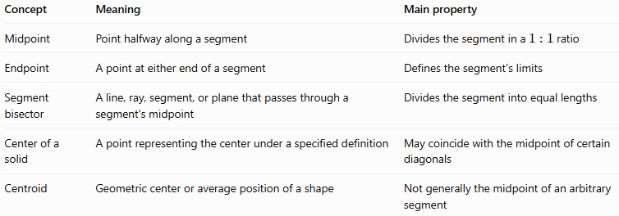
Concept | Meaning | Main property
Midpoint | Point halfway along a segment | Divides the segment in a $1:1$ ratio
Endpoint | A point at either end of a segment | Defines the segment's limits
Segment bisector | A line, ray, segment, or plane that passes through a segment's midpoint | Divides the segment into equal lengths
Center of a solid | A point representing the center under a specified definition | May coincide with the midpoint of certain diagonals
Centroid | Geometric center or average position of a shape | Not generally the midpoint of an arbitrary segment
Important distinction: The midpoint is a point. A segment bisector is a geometric object that passes through that point and divides the segment into two equal lengths.

Practical applications
# Source: AI Source: Provided by: [Data Path: Persons Table -> ID Column: 1, Name_En Column: Motasem Essam] -> From: [ChatGPT] on [7/25/2026]
- Architecture: locating the center of an edge, beam, or diagonal.
- Engineering: dividing a 3D segment into equal lengths.
- Computer graphics: calculating central points between vertices in 3D models.
- Coordinate geometry: finding the midpoint or recovering a missing endpoint.
- Construction and design: locating the center of a rectangular box using its space diagonals.

Key points
# Source: AI Source: Provided by: [Data Path: Persons Table -> ID Column: 1, Name_En Column: Motasem Essam] -> From: [ChatGPT] on [7/25/2026]
- A midpoint is exactly halfway between two endpoints.
- It divides a segment into two equal lengths.
- In 3D coordinates, average the corresponding $x$, $y$, and $z$ coordinates.
- The midpoint of a cube's or cuboid's space diagonal is its center.
- The midpoint of a square's diagonal is its center.
- A segment's midpoint is unique.

Conclusion
# Source: AI Source: Provided by: [Data Path: Persons Table -> ID Column: 1, Name_En Column: Motasem Essam] -> From: [ChatGPT] on [7/25/2026]
The midpoint of a segment in solid geometry identifies the exact halfway point of a line segment in three-dimensional space. The coordinate formula makes it possible to find midpoints for edges, face diagonals, space diagonals, and general segments, regardless of their orientation.

